West Point Excel Visualization

BUAN 4220

Samuel W. Suk

Sketch

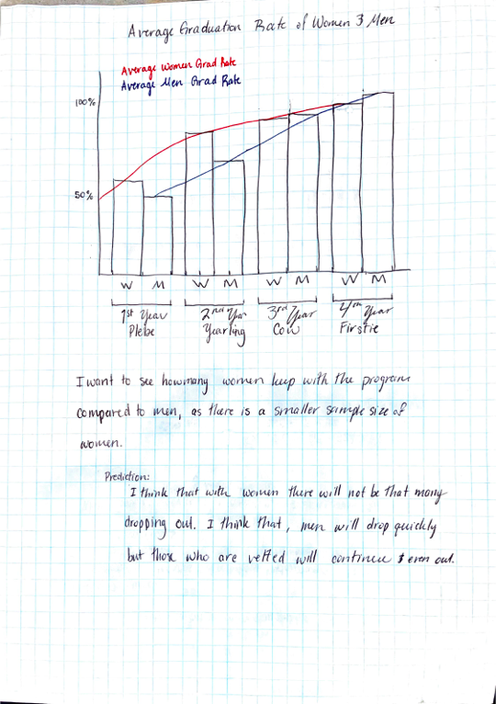

Visualization

